|  |
| --- |
| AIC, MATHEMATICS LEARNING AREA  **YEAR 12 MATHEMATICS APPLICATIONS – UNIT 3**  **Assessment Type: Response - 7%**  **TASK 4 - TEST 3 –** **Term 1, Week 9**  **CALCULATOR-ALLOWED**  **Syllabus Content:** 3.3.1 – 3.3.7 Graphs and Networks |

Student Name: __________________________________________

ID: _______ Date: _______

**TIME ALLOWED: 35 minutes** under test conditions

**Section 1: 15 minutes**

**Section 2: 35 minutes**

**MATERIAL REQUIRED / RECOMMENDED FOR THIS PAPER:**

*TO BE PROVIDED BY THE SUPERVISOR*

Question/answer booklet.

*TO BE PROVIDED BY THE CANDIDATE*

*Standard Items:* pens, pencils, pencil sharpener, highlighter, eraser, ruler. Classpad, scientific calculator

**IMPORTANT NOTE TO CANDIDATES**

No other items may be taken into the examination room. It is **your** responsibility to ensure that you do not have any unauthorised notes or other items of a non-personal nature in the examination room. If you have any unauthorised material with you, hand it to the supervisor **before** reading any further.

**Structure of this paper**

|  |  |  |  |  |
| --- | --- | --- | --- | --- |
|  | Number of questions available | Number of questions to be attempted | Suggested working time (minutes) | Marks available |
| **Calculator Assumed** | **7** | **7** | **50 minutes** | **50** |
|  | | | **Marks available:** | **/50** |
| **Task Weighting** | 7% |

**Instructions to candidates**

* The rules for the conduct of this examination are detailed in the booklet *WACE* *Examinations*

*Handbook*. Sitting this examination implies that you agree to abide by these rules.

* Answer the questions in the spaces provided.
* Spare answer pages can be used. If you need to use them, indicate in the original answer space where the answer is continued.

Question 1 (8 marks)

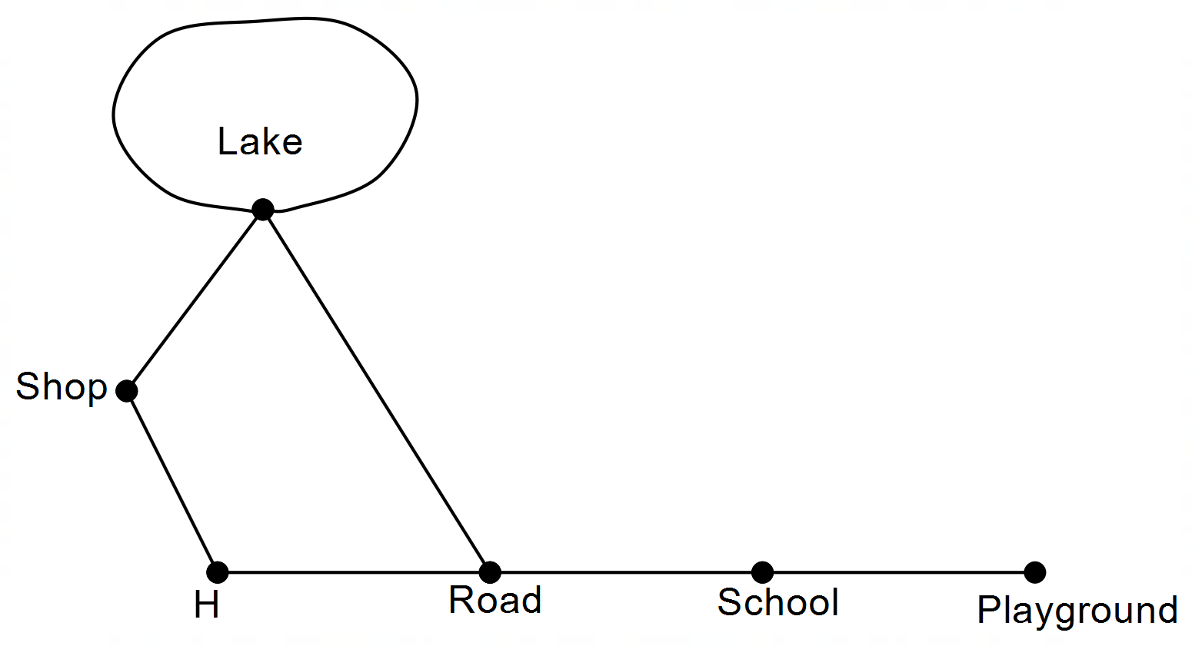Gemma has several walking paths near her home (H). The arcs on the network below show these paths.

(a) Explain why the graph is planar. (1 mark)

(b) Show that Euler’s rule is true for this graph. (2 marks)

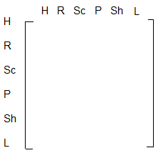(c) Construct the adjacency matrix for this graph.   
(Note: R is road, Sc is school, P is playground, Sh is shop, L is lake,) (3 marks)

(d) For Gemma to walk from home on a walk of length five, list the sequence of nodes

she would visit to:

(i) get back home. (1 mark)

(ii) get to school. (1 mark)

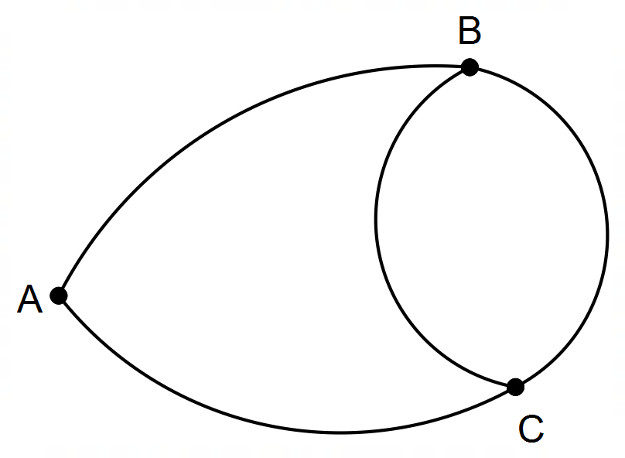**Question 2 (8 marks)**

(a) Why is the network above not simple? (1 mark)

(b) This graph is not a digraph. Why? (1 mark)

(c) This graph is semi−Eulerian. Give the reason. (1 mark)

(d) State a Hamiltonian cycle. (1 mark)

(e) How many semi−Hamiltonian paths are there starting at B? (1 mark)

A B C D

A matrix M2 =

M2 describes the two−stage paths in a simple graph.

(f) Complete the graph representing M. (3 marks)

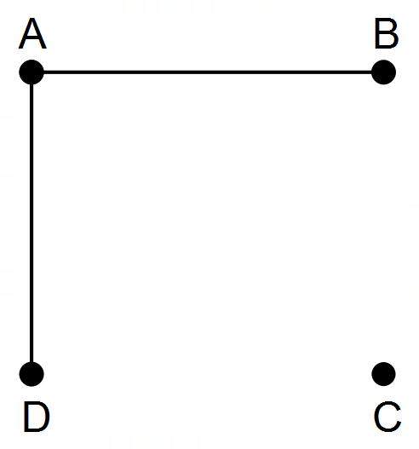

**Question 3 (9 marks)**

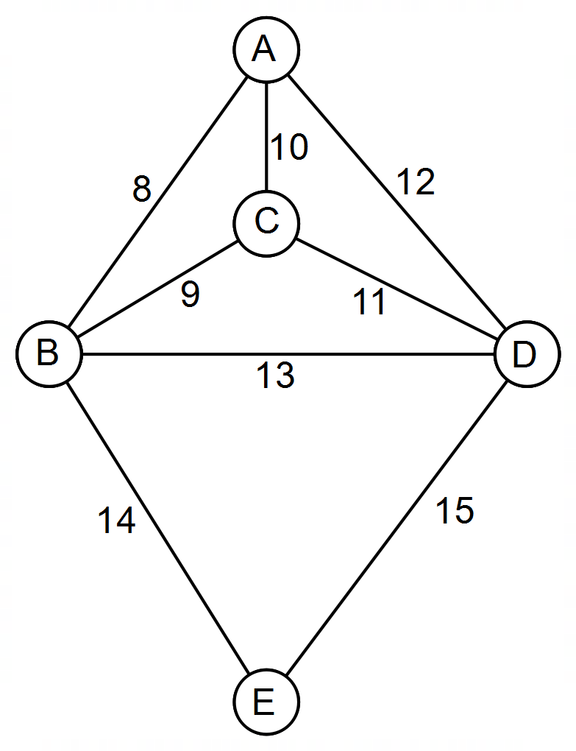Consider the following map showing five towns joined by roads. Distances are given in kilometres.

Barney is a travelling salesman, and starting from A, he wishes to visit all the other towns; B, C, D and E, and return to A by the shortest route possible in no particular order.

(a) From your knowledge of graph theory, what name is given to such a route? (2 marks)

(b) What is the shortest route he will travel? State the path and its length. (2 marks)

James is a postman and also begins at A. He wishes to travel each road delivering letters as he goes.  
Barney suggests that James can travel each road exactly once and get back to A.

(c) Barney isn’t correct. Explain. (2 marks)



*DIAGRAM REDRAWN FOR YOUR CONVENIENCE*

James thinks that if a new road was built, then he could get back to A, having only visited each road once.

(d) Where would the road be built? (1 mark)

Alyce drove a distance of 33 km, starting at a town and ending at another town.

(e) What route(s) would she have taken? (2 marks)

**Question 4 (5 marks)**

|  |  |
| --- | --- |
| **<EFOFEX>  id:fxd{107ef678-4cfb-4269-84a0-f637710bfd4c}   FXData:  </EFOFEX>** |  |

The directed bipartite graph above represents a dog agility course. Tunnels are represented by $T$ and obstacles are represented by $O$.

For example, tunnel $T_{1}$ takes dogs to obstacles $O_{1}$ and $O_{2}$, whereas once a dog has cleared obstacle $O_{5}$ they then enter tunnel $T_{3}$.

Isabel wants her dog, Jasper, to complete the agility course.

She wants Jasper to pass through all the tunnels, and to clear each obstacle, once only.

(a) (i) If Jasper is to return to where he started, what is the mathematical term for the closed path Jasper must take. (1 mark)

(ii) Explain why it is not possible for Jasper to return to his starting point without repeating a tunnel. (1 mark)

Isabel decides that Jasper does not need to return to where he started.

(b) Determine the path that allows Jasper to complete the agility course, passing through each tunnel once, and completing each obstacle once. (2 marks)

**<EFOFEX>

id:fxd{107ef678-4cfb-4269-84a0-f637710bfd4c}


FXData:

</EFOFEX>**

*DIAGRAM REDRAWN FOR YOUR CONVENIENCE*

Jasper passes through tunnel $T_{4}$ and then decides to enter tunnel $T_{3}$, skipping obstacle $O_{5}$.

(c) Why can this information not be represented in a bipartite graph? (1 mark)

Question 5 (6 marks)

(a) A connected planar graph has $14$ vertices and $9$ faces. Determine the number of edges this graph has. (2 marks)

(b) The vertices in the following graph can be split into two distinct groups to demonstrate that the graph is bipartite. List the vertices in each group. (2 marks)

(c) Determine the number of edges that must be removed from a complete graph with $5$ vertices so that it becomes a tree with $5$ vertices. (2 marks)

Question 6 (7 marks)

The edge weights on the graph below represent the time, in milliseconds, to send a data packet between routers on a computer network, represented by the vertices.

(a) Determine the minimum time to send a data packet from router $C$ to router $F$ and state, in order, the routers on this path. (3 marks)

(b) Explain, with justification, why the graph in this question is Hamiltonian. (2 marks)

(c) State, with reasoning, the least number of edges that must be removed from the graph so that it is no longer Hamiltonian. (2 marks)

Question 7 (7 marks)

A student found a box containing three keys and four padlocks. Some keys will open more than one padlock. A tick in the following table indicates that a key will open that padlock.

|  |  |  |  |  |  |
| --- | --- | --- | --- | --- | --- |
|  |  | Padlock | | | |
|  |  | $$1$$ | $$2$$ | $$3$$ | $$4$$ |
| Key | $$A$$ | ✓ | ✓ |  |  |
| $$B$$ | ✓ | ✓ | ✓ | ✓ |
| $$C$$ |  |  | ✓ | ✓ |

(a) Represent this information clearly as a bipartite graph $G$. (3 marks)

(b) The presence of all even vertices in $G$ indicates that it is Eulerian. State the definition of an Eulerian graph. (2 marks)

(c) If another edge was added to $G$, from key $A$ to padlock $4$, state, with reasons, whether $G$ is still:

(i) bipartite. (1 mark)

(ii) Eulerian. (1 mark)

**END OF TEST : EXTRA PAGE FOR WORKING**